EMBEDDED SYSTEMS LAB
FAROOQ AHMAD EXPERIMENT # 6
17L-4407 LAB REPORT # 6
EL-7B

UART MODULE IN TM4C

INTRODUCTION
In this lab session, we were introduced to the UART module in tm4c123gh6pm UART is the Universal Asynchronous Receiver Transmitter. The TM4C microcontrollers have up to 8 UART Ports (UART0-UART7). The total number of bits transmitted per second is called the baud rate. A frame is the smallest complete unit of serial transmission which includes a start bit (which is 0), 8 bits of data (least significant bit first), and a stop bit (which is 1). The communication takes place in the following way
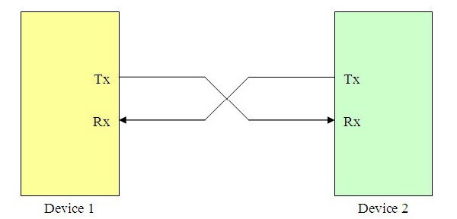
General block diagram of UART module is given below.
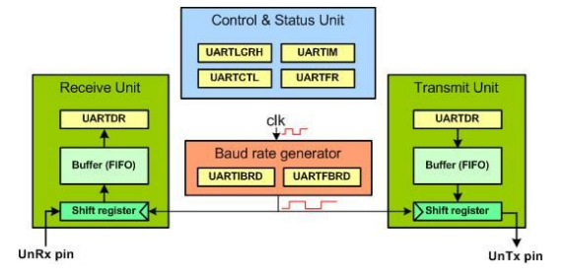
UART0 of TM4C is connected to the ICDI (In Circuit Debug Interface) which is connected to a USB connector. This ICDI USB connection can be used as virtual COM port. When the Launchpad is connected with PC, the device driver at the host PC establishes virtual connection between PC and the Launchpad as UART0. UART0 uses PA0 and PA1 pins as alternate functions for TX0 and RX0 respectively.

OBJECTIVE
The course learning objective of this lab session was to learn, understand and implement configuration of UART module and communication of tiva launch pad with PC via UART module of tm4c.

PROCEDURE
Here are the steps to configure the UART0 and transmit a byte of data for TI Tiva TM4C123GH6PM on the LaunchPad:
1) Provide clock to UART0 by writing a 1 to RCGCUART register.
2) Provide clock to PORTA by writing a 1 to RCGCGPIO register.
3) Disable the UART0 by writing 0 to UARTCTL register of UART0.
4) Write the integer portion of the Baud rate to the UARTIBRD register of UART0.
5) Write the fractional portion of the Baud rate to the UARTFBRD register of UART0.
6) Select the system clock as UART clock source by writing a 0 to UARTCC register of UART0.
7) Configure the line control value for 1 stop bit, no FIFO, no interrupt, no parity, and 8-bit data size. That gives us
0x60 for the UARTLCRH register of UART0.
8) Set TxE and RxE bits in UARTCTL register to enable the transmitter and receiver of UART0.
9) Set UARTEN bit in UARTCTL register to enable the UART0.
10) Make PA0 and PA1 pins to be used as Digital I/O.
11) Select the alternate functions of PA0 (RxD) and PA1 (TxD) pins using the GPIOAFSEL.
12) Configure PA0 and PA1 pins for UART function.
13) Wait for TxD output to establish idle high.
14) Monitor the TXFF flag bit in UART Flag register and when it goes LOW (buffer not full), write a byte to Data register to be transmitted.
LAB TASK:
Following are the functions that transmit and receive a single character to and from serial port.
void UART0Tx(char c)
{
while((UART0_FR_R & 0x0020) !=0);
UART0_DR_R = c;
}
char UART0Rx(void){
while ((UART0_FR_R&0x0010)!=0);
return ((char)(UART0_DR_R&0xFF));
}
Using UART0Tx(char) function, define another function void sendString(char*ptr) that sends a
string to serial port.
Using all these functions write a code that receives a character from PC and sends next character to
PC. Baud rate should be set to 115200.
CODE:
#include <stdio.h>
#include <stdint.h>
#include <stdbool.h>
#include "inc/tm4c123gh6pm.h"

void UART0Tx(char);
char UART0Rx(void);
void sendString(char*);

int main(void)
{
SYSCTL_RCGCUART_R |= 1; /* provide clock to UART0 */
SYSCTL_RCGCGPIO_R |= 1; /* enable clock to PORTA */

/* UART0 initialization */
UART0_CTL_R = 0; /* disable UART0 */
UART0_IBRD_R = 104; /* 16MHz/16=1MHz, 1MHz/104=9600 baud rate */
UART0_FBRD_R = 11; /* fraction part, see Example 4-4 */
UART0_CC_R = 0; /* use system clock */
UART0_LCRH_R = 0x60; /* 8-bit, no parity, 1-stop bit, no FIFO */
UART0_CTL_R = 0x301; /* enable UART0, TXE, RXE */

/* UART0 TX0 and RX0 use PA0 and PA1. Set them up. */
GPIO_PORTA_DEN_R = 0x03; /* Make PA0 and PA1 as digital */
GPIO_PORTA_AFSEL_R = 0x03; /* Use PA0,PA1 alternate function */
GPIO_PORTA_PCTL_R = 0x11; /* configure PA0 and PA1 for UART */
uint32_t i;
char x;
for (i=0;i<200000;i++);

for(;;)
{
sendString("\n\rEnter Character to send: ");

x= UART0Rx();
UART0Tx(x);

sendString("\n\rNext character is: ");
UART0Tx(x+1);
}
}
void sendString(char*ptr)
{
while(*ptr)
{
UART0Tx(*ptr);
ptr++;
}
}

void UART0Tx(char c)
{
while((UART0_FR_R & 0x0020) !=0); /* wait until Tx buffer is full */
UART0_DR_R = c; /* before giving it another byte */
}

char UART0Rx(void){
while ((UART0_FR_R&0x0010)!=0);
return ((char)(UART0_DR_R&0xFF));
}
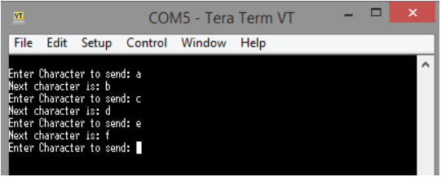

ISSUES
There were no issues.

CONCLUSION
This lab session was conducted successfully. Serial communication took place between the TM4C123GH6PM Tiva launchpad and PC via UART module port 0 in the launchpad. TM4C123G MCUs communicate with external devices or with each other over UART based serial communication protocol. Memory-mapped registers that are used to configure the UART module as a transmitter and receiver. Only two pins are used to transfer and receive data such as a transmit pin (Tx) and a receiver pin (Rx). Other two pins are just power supply pins such as ground and Vcc.

APPLICATIONS
UART stands for a universal asynchronous receiver and transmitter. It is one of the simplest wired serial communication protocols used to transfer data serially between two devices in embedded systems applications. As its name suggests, it is an asynchronous communication protocol. Therefore, no clock signal is required for synchronization between two devices. Many hardware modules such as GSM, GPS, Bluetooth, Xbee communicate with other devices or microcontrollers through UART communication. Hence, if we want to use one of these modules in your embedded systems project, we can easily interface these wireless communication modules with TM4C123G using the UART interface. The serial port allows the microcontroller to communicate with devices such as other computers, printers, input sensors and LCDs. Serial transmission involves sending one bit at a time.

POST LAB
#include <stdio.h>
#include <stdint.h>
#include <stdbool.h>
#include "inc/tm4c123gh6pm.h"
#define SW1 (GPIO_PORTF_DATA_R&0x10)
#define SW2 (GPIO_PORTF_DATA_R&0x01)

void UART0Tx(char);
char UART0Rx(void);
void sendString(char*);

void PortF_Init(void){
volatile unsigned long delay;
SYSCTL_RCGC2_R |= 0x00000020; // 1) F clock
delay = SYSCTL_RCGC2_R; // reading register adds a delay
GPIO_PORTF_LOCK_R = 0x4C4F434B; // 2) unlock PortF PF0
GPIO_PORTF_CR_R = 0x1F; // allow changes to PF4-0
GPIO_PORTF_AMSEL_R = 0x00; // 3) disable analog function
GPIO_PORTF_PCTL_R = 0x00000000; // 4) GPIO clear bit PCTL
GPIO_PORTF_DIR_R = 0x0E; // 5) PF4,PF0 input, PF3,PF2,PF1 output
GPIO_PORTF_AFSEL_R = 0x00; // 6) no alternate function
GPIO_PORTF_PUR_R = 0x11; // enable pullup resistors on PF4,PF0
GPIO_PORTF_DEN_R = 0x1F; // 7) enable digital pins PF4-PF0
}
void Delay(void){unsigned long volatile time;
time = 727240*200/91; // 0.1sec
while(time){ time--;} }

UART_Init(void){
SYSCTL_RCGCUART_R |= 1; /* provide clock to UART0 */
SYSCTL_RCGCGPIO_R |= 1; /* enable clock to PORTA */

/* UART0 initialization */
UART0_CTL_R = 0; /* disable UART0 */
UART0_IBRD_R = 104; /* 16MHz/16=1MHz, 1MHz/104=9600 baud rate */
UART0_FBRD_R = 11; /* fraction part, see Example 4-4 */
UART0_CC_R = 0; /* use system clock */
UART0_LCRH_R = 0x60; /* 8-bit, no parity, 1-stop bit, no FIFO */
UART0_CTL_R = 0x301; /* enable UART0, TXE, RXE */

/* UART0 TX0 and RX0 use PA0 and PA1. Set them up. */
GPIO_PORTA_DEN_R = 0x03; /* Make PA0 and PA1 as digital */
GPIO_PORTA_AFSEL_R = 0x03; /* Use PA0,PA1 alternate function */
GPIO_PORTA_PCTL_R = 0x11; /* configure PA0 and PA1 for UART */
}
void UART0Tx(char c)
{
while((UART0_FR_R & 0x0020) !=0); /* wait until Tx buffer is full */
UART0_DR_R = c; /* before giving it another byte */
}

char UART0Rx(void){
while ((UART0_FR_R&0x0010)!=0);
return ((char)(UART0_DR_R&0xFF));
}
void sendString(char*ptr)
{
while(*ptr)
{
UART0Tx(*ptr);
ptr++;
}
}

int main(void)
{
PortF_Init(); // Call initialization of port PF0-PF4
UART_Init();
while(1){

if(!SW1){
sendString("\n\r SW1 is pressed ");
Delay(); // wait 0.1 sec
}
else if(!SW2){
sendString("\n\r SW2 is pressed");
Delay(); // wait 0.1 sec
}
}

